Life Hospital System

Requirements Specification and Analysis

Version 0.1

17.11.2017

Selin Atalay

Tolga Şıvgın

Murat Akalın

Hasan Cihan Akpınar

Prepared for

SE301 Software Engineering



Table of Contents

1. Introduction 1

1.1. Purpose of the System 1

1.2. Scope of the System 1

1.3. Objectives and Success Criteria of the Project 1

1.4. Definitions, Acronyms, and Abbreviations 1

1.5. Overview 1

2. Current System 2

3. Proposed System 2

3.1. Overview 2

3.2. Functional Requirements 2

3.3. Nonfunctional Requirements 5

3.4. System Models 5

Scenarios 6-13

Use case model 14-26

Object model 27

**Dynamic model** 27-40

3.5. Project Schedule…………………………………………………………...41

4.Glossary 41-42

5.References **42**

6. Mockups…………………………………………………………………………….42

REQUIREMENTS ANALYSIS DOCUMENT

# Introduction

## Purpose of the System

* Life Hospital System (LHS) is a web-based application that provides the users get appointment from the hospital. It is like hospital automation.
* There are two level of users;

1. User
2. Administration
3. Staff

* We will call Life Hospital System as LHS.
* LHS includes a few information about the user (patient) like name, surname, and appointment date etc. for future usage.
* LHS provides user to list the available date and the personal (doctors) to get appointment in that time interval.
* LHS generates reports for the appointment information and identification number for that appointment.

## Scope of the System

* The system will be used to get social and personal information from the patient and creating an online appointment by using that information.
* The system will be stored data for every staff and patient.
* The system will be used to list of the patients, their quick information and their appointment information.

## Objectives and Success Criteria of the Project

* Proper and conducive project plan
* Assigning tasks to the team members by using GitHub.
* Reviewing and doing a rework when needed.
* Managing project risks efficiently.
* Allocating time for process improvement

## Definitions, Acronyms, and Abbreviations

LHS: Life Hospital System.

## Overview

* After this section, you will be facing with cases, our models, system requirements, glossary of the system.
* RAD is organized on our group member’s meeting.

# Current System

Current system is not available. Because, the hospital is new.We will create a new system for it. When User (patient) registered system, this system provides you to get any appointment from any departments in hospital, he/she can reach laboratory results or doctors and departments information.We can call this system as Life Hospital System.

# Proposed System

First of all, this system offers the possibility to choose according to status of user. If user is patient, login on system and he/she get an appointment from this system. Also this system offer opportunity to cancel appointment.Other user is Hospital Personel which is setting available doctors times, adding laboratory results on system and editing patients’ appointments on system.Finally, users have knowledge about hospitals’ vision and mission on this website.

## Overview

Life Hospital System offers users the option of it easier and faster procedure. Also, it could be solution to prevent the confusion which may occurs when an appointment and appointment get tracking. Because of all these reasons we can reach the large masses in accordance with the purpose of this project.

## Functional Requirements

* + 1. **User Mode**
* **Register;**

Patients may register on the system with required information.İf users not registered in the system, they can login the system after registered

* **Request Password Reminder;**

When patient forgot his/her password, use reminder password button to remember password.

* **Authentication;**

Patients can enter the system with own SSN number and password which is created by own on register. Patients who is previously registered in the system can access next step from this part.

* **Book an Appointment;**

When patients enter get appointment option, they do selection hospital, department, doctor, day and hour step by step.

* **Save an appointment;**

After he or she checked appointment’s information on the page which is show patient’s choosing if all information are true he/she click the save button and get an appointment.

* **Cancel an appointment;**

Patient’s all appointment showing same page on system. Patient click the appointment button if patient is not going to go to appointment then he can cancel which he wants.

* **Logs Off;**

Patients exit the system when they finished their operations on the system.

* + 1. **Hospital Personel mode**
* **Authentication;**

Hospital Personel can login on system with SSN number and password.

* **Add Laboratory Results ;**

Hospital Personel can add patient’s laboratory results on system with patient’s information.

* **Edit Laboratory Results ;**

If necessary, Hospital Personel can edit patient’s laboratory results on system with patient’s information.

* **Set Available Date for Doctor ;**

First of all Hospital Personel choose department which he/she is work there. Then enter information (doctor, date and hour) which are contained monthly work program.Monthly program is given to him/her by doctors.

* **Edit appointment information;**

Hospital Personel update information which must be change, on saved program by Hospital 9Personel.

* **Save;**

Hospital Personel record all doctors’ programs on the system when he or she entered all informations.

* **Log Off;**

Personnel exit the system when they finished the operations on the system.

* + 1. **Admin mode**
* **Authentication;**

Admin can login on system with SSN number and password.

* **Reach List Of Doctors;**

Admin can reach list of doctors.Admin can add, edit or delete doctors in this list.Then Admin updates which is necessary such as a doctor come to work the hospital.

* **Reach List Of Personels;**

Admin can reach list of personels.Admin can add, edit or delete personels in this list.Then Admin updates which is necessary such as a personels come to work the hospital.

* **Reach List Of Policlinics;**

Admin can reach list of policlinics.Admin can add, edit or delete policlinics in this list.Then Admin updates which is necessary such as a policlinics in the hospital.

* **Log Off;**

Admin exit the system when they finished their operations on the system.

## Nonfunctional Requirements

* Usability

Program should be use easily by People who have the average information about using computer .It must be usable at any time.

* Reliability

People can’t access personal information which recorded on database by developer.

* Performance

This system must be quick.

It supports more than one user at same time. But it is not developed to people who are take appointment at the same time and same appointment.

Information which are uploads on database must be updatable according to the requirements.

* Supportability

Developer will be responsible to provide continuance, compatibility and testability on created program.

* Implementation

Design of database done with MySql SERVER 2012

Visual Studio 2012 will be used as coding IDE.

Asp.Net C# Object Oriented will be used as programming language.

* Interface

Application can use on devices which have Internet and its browser should be usable.

* Packaging

System’s all steps as a package are within GitHub.

* Legal

Project’s all contents are protected by the law of copyright.

Describe the scenarios, use cases, object model, and dynamic models for the system. This section contains the complete functional specification, including mock-ups illustrating the user interface of the system and navigational paths representing the sequence of screens.

* ***Scenarios***

## Scenario 1

|  |
| --- |
| **Scenario name:** Edit and add Doctor |
| **Participant actor instances: Tolga:**Admin **Selin**:Doctor |

|  |
| --- |
| System Models**Flow of events:**   1. Tolga add to Selin and she wants to add or edit these information to the system. 2. Firstly Tolga writes lifehospital.com on browser. 3. Tolga sees login pages and she enter TC number into TC number text field also enter password into Password text field on this pages. 4. If TC number,password and role match to information which are in LFH database Tolga can login to the LFH. |

## Scenario 2

|  |
| --- |
| **Scenario name:** Adding Doctor |
| **Participant actor instances: Murat:**Admin **Selin:**Doctor |
| **Flow of events:**   1. Murat hears that Selin came to the same hospital with Murat. 2. Firstly Murat logs into the LFH. 3. Murat selects “Add Doctor” button. 4. Murat fills the related field with the personal information of the Selin. 5. Then Murat click “save” button. 6. LFH save the Selin’s personal informations on database . 7. Murat sees a "Saved successfully" message on screen.Then Murat logs of. |

## Scenario 3

|  |
| --- |
| **Scenario name:** Deleting Doctor |
| **Participant actor instances: Hasan:**Admin **Selin:**Doctor |
| **Flow of events:**   1. Hasan hears that Selin leave to the same hospital with Hasan. 2. Firstly Hasan logs into the LFH. 3. Hasan selects “Delete Doctor” button 4. He sees all doctor who work the same hospital with Hasan. 5. Hasan chooses Selin. 6. Then Hasan click “save” button. 7. LFH finds the Selin on database and delete her all informations on system. 8. The message shown on screen that “The doctor is deleted successfully”. 9. Hasan logs of. |

## Scenario 4

|  |
| --- |
| **Scenario name:** Books Appointment |
| **Participant actor instances:** Cihan:Patient |
| **Equipment:** Any computer with a supported browser. |
| **Flow of events:**   1. Cihan starts browser and types URL of the LFH system. 2. Cihan authenticates. 3. Cihan list options of the system. 4. Cihan clicks the option ‘book appointment’. 5. Cihan list available departments, doctors and the date of the examination. 6. Cihan selects Department A, 29.06.2016 12:00 as a date with the Doctor B. 7. Cihan clicks ‘book appointment’ button to get appointment. 8. Cihan is navigated by the LFH system to confirmation page. 9. Cihan checks his appointment details. 10. Cihan clicks ‘confirm’ button to send LFH system a confirmation request. 11. Cihan logs off. |
| **Entry Condition:** Cihan wants to get an appointment from a specific hospital and date. |
| **Exit Condition:** There is no available date for Cihan – OR – Cihan cannot login to the LFH system. |

***Scenario 5***

|  |
| --- |
| **Scenario name:** Mark an Appointment |
| **Participant actor instances:** Doctor,Patient and Personnel |
| **Flow of events:**   1. Doctor prepares an appointment ‘s mothly program and he/she gives this program to personnel. 2. Personnel login the system and clicks the edit appointment button. 3. Personnal enters this program in this system and clicks the save button. 4. Then,patient login the system to book an appointment. 5. Patient choose department,doctor,day and time step by step. 6. Patient clicks ? (randevu kaydet butonu)? 7. Doctor opens the system when he/she Works to view a Daily appointment. 8. Patient goes to hospital for his/her appointment. 9. Doctor Views this appointment on the page that shows the appointment . 10. When this appointment comletes,doctor mark it in the box which is across the appointment’s informations. 11. Personal click save button to save final of table. |

***Scenario 6***

|  |
| --- |
| **Scenario name:** Request Password |
| **Participant actor instances:** Personal |
| **Flow of events:**   1. User URL girer 2. User clicks login button 3. New Page opens that login the system. 4. If personal can not remember his/her password ,user directly clicks the password reminder button. 5. System sets an e-mail to his/her e-mail address. 6. Or personal enters his/her password and TC number. 7. System checks the TC number and password that stored in the database. 8. If his/her TC number and password do not match the database system give an error and system shows this error as a message on screen. 9. Personal see message on screen. 10. He/She try one more time to login system. 11. He/She can not login the system results of these trying. 12. Personal clicks the password reminder because of this reason and open new page. 13. Personal enters his/her e-mail in the box which is seperated to enter e-mail. 14. System sents his/her password by using e-mail. 15. Then Personal enter his/her e-mail and see password. 16. Finally,personal login the system with this password. |

***Scenario 7***

|  |
| --- |
| **Scenario name:** Login for Patient |
| **Participant actor instances:** Cihan: Patient |
| **Equipment:** Any computer with a supported browser. |
| **Flow of events:**   1. Cihan starts browser and types URL of the LFH system. 2. Cihan clicks to the login button. 3. Cihan is navigated to the ‘login’ page by the LFH system. 4. Cihan fills the needed information TC and Password. 5. LFH system checks the information which is entered by Cihan. 6. If the TC and password match with the TC and password which is stored in database. Cihan authenticates. |
| **Entry Condition:** Users want to get an appointment and visits the LFH Home Page and choose patients |
| **Exit Condition:** TC number which entered user and TC number which registered on database is not matching. |

### **Scenario 8**

|  |
| --- |
| **Scenario name:** Cancel an Appointment |
| **Participant actor instances:** Cihan: Patient |
| **Equipment:** Any computer with a supported browser. |
| **Flow of events:**   1. Cihan starts browser and types URL of the LFH system. 2. Cihan authenticates. 3. Cihan list options of the system. 4. Cihan clicks the option ‘list appointments’. 5. Cihan list his appointment which he already booked. 6. Cihan is navigated by the LFH system to the ‘list appointment’ page. 7. Cihan clicks one of his appointments. 8. Cihan is navigated by the LFH system to the ‘appointment-information’ page. 9. Cihan clicks ‘cancel this appointment’ to delete from his book. 10. The appointment is canceled by Cihan. 11. Cihan clicks LFH system logo to redirect to patient-dashboard. 12. Cihan clicks logs off. 13. Cihan logs off. |
| **Entry Condition:** Users want to get an appointment and visits the LFH Home Page and choose patients |
| **Exit Condition:** TC number which entered user and TC number which registered on database is not matching. |

### **Scenario 9**

|  |
| --- |
| **Scenario name:** List Appointment |
| **Participant actor instances:** Cihan: Patient |
| **Equipment:** Any computer with a supported browser. |
| **Flow of events:**   1. Cihan starts browser and types URL of the LFH system. 2. Cihan authenticates. 3. Cihan list options of the system. 4. Cihan clicks the option ‘list appointments’. 5. Cihan list his appointment which he already booked. 6. Cihan is navigated by the LFH system to the ‘list appointment’ page. 7. Cihan clicks one of his appointments. 8. Cihan is navigated by the LFH system to the ‘appointment-information’ page. 9. Cihan checks his appointment information which is detailed. (Hospital, department, date etc.) 10. Cihan clicks LFH system logo to redirect to patient-dashboard. 11. Cihan clicks logs off. 12. Cihan logs off. |
| **Entry Condition:** Cihan wants to list one of his appointment information. |
| **Exit Condition:** There is no current appointment in Cihan’s book. |

### **Scenario 10**

|  |
| --- |
| **Scenario name:** Half the remainin Appointments |
| **Participant actor instances: Tolga:**Patient |
| **Flow of events:**   1. Tolga starts browser and types URL of the LFH system. 2. Tolga enter her TC number. 3. Tolga enter her password. 4. Tolga click login button and enter the system 5. Tolga choose hospital than click departments part 6. Choose department according to her disease 7. She gave up to get an appointment 8. After that she close the page when she does not click the books an appointment button 9. Finally she will be log off. |

### **Scenario 11**

|  |
| --- |
| **Scenario name:** Editing working program |
| **Participant actor instances:Tolga:**Personnel **Selin:**Doctor |
| **Flow of events:**   1. Selin have a illness and she received report for once a week.Therefore Tolga’s appointment program must be change. 2. Firstly Tolga logs into the LFH. 3. Tolga selects “Edit working” button 4. She sees all doctor who work the same hospital with Tolga. 5. Tolga chooses Selin. 6. Then change Selin’sprogram according to report. 7. She click “save” button. 8. LFH find Selin and her appointment on database and update appointment information. 9. The Message shown on screen that “The program is update successfully”. 10. Tolga logs of. |

### **Scenario 12**

|  |
| --- |
| **Scenario name:** Setting Working Program |
| **Participant actor instances: Hasan:**Personel **Selin:**Doctor |
| **Flow of events:**   1. Hasan takes monthly programs to Selin and he wants to add these information to the system. 2. Firstly Hasan logs in to LFH. 3. When Hasan selects appointment program button, sees doctors who work the same hospital with Hasan. 4. Then Hasan choose a doctor one by one. 5. Hasan add Selin‘s monthly program as date and hour on the system. 6. Hasan click “save” button when he added all iformation on the system. 7. LFH edit this appointment and saves it in to the appointment table on the database. 8. Hasan successfully completed that adding appointment information. 9. He logs of the system. |

### **Scenario 13**

|  |
| --- |
| **Scenario name:** Edit Doctor working Program |
| **Participant actor instances: Hasan:**Personel **Selin:**Doctor |
| **Flow of events:**   1. Hasan takes monthly programs to Selin and he wants to add these working schedule to the system. 2. Firstly Hasan logs in to lfh. 3. When Hasan selects workings program button, sees doctors who work the same hospital with Hasan. 4. Then Hasan choose a doctor one by one. 5. Hasan add Selin’s monthly program as date and hour on the system. 6. Hasan click “save” button when he added all iformation on the system. 7. LFH edit this appointment and saves it in to the appointment table on the database. 8. Hasan successfully completed that adding appointment information. 9. He logs of the system. |

* ***Use Case***

**Use case 1:**

|  |
| --- |
| **Use case name:** Register |
| **Participant actors:** Patient |
| **Flow of events:**   1. User starts browser and types URL of the LFH system 2. User click patients button. 3. User click register button. 4. User fill blank his/her Personal information. 5. User create a new password on password field. |
| **Entry Condition:** Users want to get an appointment and visits the LFH Home Page and choose patients |
| **Exit Condition:** TC number which entered user and TC number which registered on database is not matching. |

**Use case 2:**

|  |
| --- |
| **Use case name:** Login Personnel |
| **Participant actors:** Personel |
| **Flow of events:**   1. Personnel starts browser and types URL as [www.lifehospital.com/personnel](http://www.lifehospital.com/personnel) of the LFH system. 2. Personnel sees the login page and enter his/her TC number into text field also enter password into Password text field on this pages. 3. When he/she clicks login button LFH checks the TC number, password and role. 4. If the personnel informations match the LFH database information personnel can login. |
| **Entry Condition**:The personnel enter the login screen. |
| **Exit Condition:** The personnel logs in successfully. |
| **Quality Requirements:** 3*If personnel entered missing information LFH displays a warning that “You have entered missing information”.  4* If information are not match on database or role is different from personnel displays a warning message that “Your TC number or Password is wrong.” |

**Use case 3:**

|  |
| --- |
| **Use case name:** Set Appointment Program |
| **Participant actors:** Personnel and Doctor |
| **Flow of events:**   1. A doctor wants to make difference from his/her monthly program. 2. Personnel logs in the LFH system. 3. LFH show option that add/delete doctor,set appointment,edit appointment a main page.He/she click “Edit Appointment” button on this page. 4. Then she/he chooses a doctor who want to make difference. 5. Personnel change the appointment program according to Doctor’s request. 6. He/she click “Save” button and LFH shows a messages that “The program is update successfully” 7. Finally Personnel logs of. |
| **Entry Condition:**Personnel has created a appointment program.OR  Personnel choose “Edit Appointment Program” button. |
| **Exit Condition:**Personnel edit and save the appointment program successfully.OR  LFH show a message that explains why the editing could not be done successfully |
| **Quality Requirements:**2*When personnel logs in system if he/she enter wrong information ,database displays a warning message that “Your TC number or Password is wrong.”  4* If personnel does not choose a doctor from doctors list, system displays a warning message that "You must choose a doctor".  6*İf personnel logs of the system without clicking “save” button,information are not save. |

**Use case 4:**

|  |
| --- |
| **Use case name:** Add Doctor |
| **Participant actors:** Personnel |
| **Flow of events:**   1. Personnel logs in the LFH system. 2. LFH show option that add/delete doctor,set appointment,edit appointment a new page.He/she click “Add Doctor” button on this page. 3. Personnel fills the field with informations of the new doctor. 4. He/she click “save” button and LFH shows a messages that “The doctor is saved successfully” 5. LFH add informations into Doctor and Person table on database. 6. Finally Personnel logs of. |
| **Entry Condition:**The personnel want to add information about a new doctor who coming hospital. |
| **Exit Condition:** LFH save the informations which entered by Personnel to the database and personnel returns to the home page. |
| 1*When personnel logs in system if he/she enter wrong information ,database displays a warning message that “Your TC number or Password is wrong.”  4* If personnel does not fill all fields on set appointment program page there is a warning that “You have entered missing information”appears on screen. |

**Use case 5:**

|  |
| --- |
| **Use case name:** Delete Doctor |
| **Participant actors:** Personnel |
| **Flow of events:**   1. Personnel logs in the LFH system. 2. LFH show option that add/delete doctor,set appointment,edit appointment a new page.He/she click “Delete Doctor” button on this page. 3. Then she/he see all doctor who work with she/he and chooses a doctor who leaving the hospital. 4. He/she click “Save” button and LFH shows a messages that “The doctor is deleted successfully” 5. LFH delete informations which are in Doctor table on database. 6. Finally Personnel logs of. |
| **Entry Condition:** A doctor leave the hospital so LFH system must be updated.OR  Personnel choose “Delete Doctor” button. |
| **Exit Condition:**System delete informations on database and personnel returns to the home page. |
| **Quality Requirements:** 1*When personnel logs in system if he/she enter wrong information ,database displays a warning message that “Your TC number or Password is wrong.”  3* If personnel does not choose a doctor from doctors list, system displays a warning message that "You must choose a doctor".  4*İf personnel logs of the system without clicking “save” button,deleting are not save on system.  5*İf database is not find the deleting doctor, it displays a "This doctor is not find on system" message. |

**Use case 6**

|  |
| --- |
| **Use case name:** Update Polyclinic |
| **Participant actors:** Initiated by Administrator |
| **Flow of events:**  1. Administrator clicks the "Update Polyclinic Informations" button.  2. System the screen which selected Polyclinic informations is displayed by retrieving the informations from database.  3. Administrator fills the necessary fields that is going to be changed.  4. Administrator clicks "Save" button.  5. System displays a "Saved successfully!" message on a dialogue box.  6. System redirects the administrator to the administrator main page. |
| **Entry Condition:** Administrator logs in to the LFH System.  Administrator displays the screen which hospitals are listed. |
| **Exit Condition:** Administrator clicks "Save" button and system redirects him/her to the administrator main page. |
| **Quality Requirements:** 1*. If administrator does not select any polyclinic from the list, system displays a warning message, like "Please select a polyclinic to update.".  3*. If administrator leaves an area empty, system displays a warning message.  4*. If administrator closes the page without saving, system does not save the informations.  4**. If administrator clicks the "Update Clinics" button, system fetches the screen that list of clinics is displayed. |

**Use case 7**

|  |
| --- |
| **Use case name:** Update Personal |
| **Participant actors:** Initiated by Administrator |
| **Flow of events:**   1. Administrator changes necessary areas to update and clicks the "Update" button. 2. System saves the new informations to the database. 3. System displays a "Update successfully!" message on a dialogue box. 4. Administrator clicks "Back" button. 5. System redirects the administrator to the administrator main page. |
| **Entry Condition:** Administrator logs in to the LFH System.  Administrator displays personal informations screen. |
| **Exit Condition:** Administrator clicks "Back" button and system redirects administrator to his/her main page. |
| **Quality Requirements:** 1*. If administrator leaves a field empty, system displays a warning message, like "This area can not be empty.".  1**. If administrator closes the page without saving, system does not save the informations.  3*. If system fails to save informations to the database, it displays a "saving is unsuccessful" message. |

**Use case 8**

|  |
| --- |
| **Use case name:** Login |
| **Participant actors:** Initiated by Administrator |
| **Flow of events:**   1. Administrator displays the login screen of the application. 2. Administrator enters username and password to the related areas. 3. Administrator clicks "Login" button. 4. System checks the informations from database. 5. System fetches the main screen of administrator. |
| **Entry Condition:** 1. Administrator displays the login screen of the system.  Administrator saves his/her informations to the database. |
| **Exit Condition:** Administrator clicks "Login" button and system displays the administrator main page. |
| **Quality Requirements:** 2*. If administrator leaves one or more fields empty, system displays a warning message, like "This area can not be empty.".  4*. If the informations checked from database are not true, system displays a warning message, like "Wrong username or password, please retry.". |

**Use case 9**

|  |
| --- |
| **Use case name:** ListPersonnels |
| **Participant actors:** Initiated by Administrator |
| **Flow of events:**   1. Administrator clicks the "List Personnels" button on administrator main page. 2. System fetches the screen which list of personnels can be displayed. 3. Administrator clicks "Back" button. 4. The system directs administrator to his/her main page. |
| **Entry Condition:** Administrator logs in to the LFH System.  Administrator displays his/her main page. |
| **Exit Condition:** Administrator clicks "Back" button and system directs administrator to his/her main page. |
| **Quality Requirements:** None. |

**Use case 10**

|  |
| --- |
| **Use case name:** Logout |
| **Participant actors:** Initiated by Administrator |
| **Flow of events:**   1. Administrator clicks "Logout" button. 2. System redirects administrator to the login page. |
| **Entry Condition:** Administrator logs in to the LFH System.  Administrator displays his/her main page. |
| **Exit Condition:** Administrator clicks "Logout" button and system redirects administrator to the login page. |
| **Quality Requirements:** None. |

**Use case 11**

|  |
| --- |
| **Use case name:** Add New Personnel |
| **Participant actors:** Initiated by Administrator |
| **Flow of events:**   1. Administrator clicks "Add New Personnel" button. 2. System fetches the screen that new personnel can be added. 3. Administrator fills the related areas with the personal information of the new personnel. 4. Administrator clicks "Save" button. 5. System saves the new personnel and his/her informations to the database. 6. System displays a "Saved successfully!" message on a dialogue box. 7. System redirects administrator to the administrator main page. |
| **Entry Condition:** Administrator logs in to the LFH System.  Administrator displays his/her main page. |
| **Exit Condition:** System saves the new personnel and his/her informations to the database, then system displays a "Saved successfully!" message and system redirects administrator to the administrator main page. |
| **Quality Requirements:** 3*. If administrator leaves a field empty, system displays a warning message, like "This area can not be empty.".  4*. If administrator closes the page without saving, system does not save the informations.  6*. If system fails to save informations to the database, it displays a "saving is unsuccessful" message. |

**Use case 12**

|  |
| --- |
| **Use case name:** Delete Personnel |
| **Participant actors:** Initiated by Administrator |
| **Flow of events:**   1. Administrator selects a personnel that is going to be deleted. 2. Administrator clicks the "Delete Personnel" button. 3. System deletes the selected personnel record from database. 4. System displays a "Deleted successfully!" message on a dialogue box. 5. System reloads the personnel list screen. |
| **Entry Condition:** . 1.Administrator logs in to the LFH System.  2. Administrator displays the screen that list of personnels is displayed. |
| **Exit Condition:** System displays a "Deleted successfully!" message and system reloads the personnel list screen. |
| **Quality Requirements:** 1*. If administrator does not select a personnel from personnel list, system displays a warning message, like "A selection must be done to delete".  4*. If system fails to delete informations from the database, it displays a "deleting is unsuccessful" message. |

**Use case 13**

|  |
| --- |
| **Use case name:** Books Appointment |
| **Participant actors:** Patient |
| **Flow of events:**  1. Patient type URL adress of the LFH system to the browser.  2. Patient enter his/her TC and password and send LFH system an login request if the TC and password match with the TC and password which is stored in database, Patient authenticates.  3. Patient clicks ‘book appointment’ button to be navigated to the book appointment page.  4. LFH system provides available dates for specific doctor, departments and polyclinic in the books appointment page.  5. Patient select polyclinic, date, doctor and department to book an appointment.  6. Patient clicks ‘send for approval’ to get appointment. LFH system check the information which is provided by the patient. LFH system navigate patient to the confirmation page.  7. Patient checks his/her information which he/she selected in the book appointment page.  8. Patient confirm his/her information.  9. Patient get the appointment. |
| **Entry Condition:** Patient wants to get an appointment. |
| **Exit Condition:** Patient can’t authenticate with the LFH system. - OR - There is no available date for the Patient. |

**Use case 14**

|  |
| --- |
| **Use case name:** List Appointments |
| **Participant actors:** Patient |
| **Flow of events:**   1. Patient type URL adress of the LFH system to the browser. 2. Patient enter his/her TC and password and send LFH system an login request if the TC and password match with the TC and password which is stored in database, Patient authenticates. 3. Patient clicks ‘list appointments’. 4. LFH system navigate Patient to the list appointment page. 5. Patient select his/her appointment. 6. LFH system navigate Patient to the appointment information page. 7. Patient check his appointment information. |
| **Entry Condition:** Patient wants to list his/her appointment information. |
| **Exit Condition:** Patient can’t authenticate with the LFH system. - OR - There is no current appointment in Patient-dashboard. |

**Use case 15**

|  |
| --- |
| **Use case name:** Edit the Appointment |
| **Participant actors:** Patient |
| **Flow of events:**  1. Patient type URL adress of the LFH system to the browser.  2. Patient enter his/her TC and password and send LFH system an login request if the TC and password match with the TC and password which is stored in database, Patient authenticates.  3. Patient clicks ‘book appointment’ button to be navigated to the book appointment page.  4. LFH system provides available dates for specific doctor, departments and polyclinic in the books appointment page.  5. Patient select polyclinic, date, doctor and department to book an appointment.  6. Patient clicks ‘send for approval’ to get appointment. LFH system check the information which is provided by the patient. LFH system navigate patient to the confirmation page.  7. Patient checks his/her information which he/she selected in the book appointment page.  8. Patient clicks the edit the appointment.  9. Patient is navigated to the page ‘book appointment’.  10. Patient fill the wrong filled boxes again.  11. Patient clicks ‘send for approval’ to get appointment.  12. LFH system check the information which is provided by the patient. LFH system navigate patient to the confirmation page.  13. Patient confirm his information. |
| **Entry Condition:** Patient wants to edit his appointment before he/she get it. |
| **Exit Condition:** Patient can’t authenticate with the LFH system. |

**Use case 16**

|  |
| --- |
| **Use case name:** Cancel an Appointment |
| **Participant actors:** Patient |
| **Flow of events:**   1. Patient type URL adress of the LFH system to the browser. 2. Patient enter his/her TC and password and send LFH system an login request if the TC and password match with the TC and password which is stored in database, Patient authenticates. 3. Patient clicks list appointment. 4. LFH system navigate Patient to the list appointment page. 5. Patient select his/her appointment which he/she want to make a difference on it. 6. LFH system navigate Patient to the appointment information page. 7. Patient selects the ‘cancel the appointment’ section. 8. Patient cancels the appointment. 9. LFH system automatically navigate Patient to the patient-dashboard page. |
| **Entry Condition:** Patient wants to get an appointment. |
| **Exit Condition:** Patient can’t authenticate with the LFH system. - OR - There is no current appointment in Patient-dashboard. |

**Use case 17**

|  |
| --- |
| **Use case name:** Login for Patient |
| **Participant actors:** Patient |
| **Flow of events:**   1. Patient type URL adress of the LFH system to the browser. 2. Patient clicks login section. 3. Patient is navigated to the login page by LFH system. 4. Patient fills the TC and Password fields. 5. Patient clicks to the login button. 6. By clicking login button Patient sends a login request to the LFH system. 7. LFH system checks the TC and Password with the data which is stored while the Patient registered if the information match patient authenticates. |
| **Entry Condition:** Patient wants to login to the system. |
| **Exit Condition:** Patient is not registered. - OR – Patient forgot his account details. |

**Use case 18**

|  |
| --- |
| **Use case name:** Mark an Appointment |
| **Participant actors:** Patient |
| **Flow of events:**  1. Main page that includes a patient login button, patient login button and register button opens.  2. User(patient) enter password and TC number to login the system.  3. User clicks the patient login button.  4. The patient is logged in the system.  5. The patient(user) clicks the view an appointment button to display the appointment system previously recorded by staff.  6. When user click the button,new page open that include appointments.  7. Patient follow his/her all appointments from this page.  8. If patient come to his/her appointment,system mark an this appointment.  9. When all appointment finished,user log off. |
| **Entry Condition:** *User login the system.  *User must click the view an appointment button.  *User(patient) wants to view an appointments. |
| **Exit Condition:** *Users can not login.  * If there is no registered appointment on the System  * There isn’t any patient come to hospital for their appointments. |
| **Quality Requirements:** 2* If User enter password incorrect,system displays “your password is incorrect”.  5*System displays “you have not an appointment for today”message if there is no registered appointment on the system . |

**Use case 19**

|  |
| --- |
| **Use case name:** Password Reminder |
| **Participant actors:** Patient |
| **Flow of events:**   1. User starts browser and types URL of the LFH. 2. Main page that includes a patient login button and register button opens. 3. User clicks the patient login button. 4. User(patient) enter incorrect password or forget his/her password. 5. If still unable to login to the system,user clicks password reminder button. 6. System open new page to password reminder. 7. Then,user enter e mail address in the releated part on this page. 8. System send his/her password to e-mail adrees that entered by user. 9. Finally he/she log off |
| **Entry Condition:** *User want to login on this system and he/she can not remember his/her password.  *To view an appointment.  *To follow his/her appointment |
| **Exit Condition:** * Users received an e-mail that include password or give up to login the system. |
| **Quality Requirements:** 4**\***System displays a “incorrect password” message if user enter incorrect password.  5*User can try enter password one or more time. |

**Use case 21**

|  |
| --- |
| **Use case name:** Forget password |
| **Participant actors:** Patient, OR Personel, |
| **Flow of events:**   1. When user authenticate he/she forget the password. 2. He/she click Password reminder button. 3. User enters his/her TC number. 4. LFH checks if the TC number on database and send a mail which have a new password to user’s mail. 5. User check his/her mail. 6. Users can login with password which received by e-mail. |
| **Entry Condition:** User forgot password. |
| **Exit Condition:** User can not access e-mail. |

**Use case 22**

|  |
| --- |
| **Use case name:** Register |
| **Participant actors:** Patient |
| **Flow of events:**   1. User starts browser and types URL of the LFH system 2. User click patients button. 3. User click register button. 4. User fill blank his/her Personal information. 5. User create a new password on password field. |
| **Entry Condition:** Users want to get an appointment and visits the LFH Home Page and choose patients |
| **Exit Condition:** TC number which entered user and TC number which registered on database is not matching. |

**Diagram**

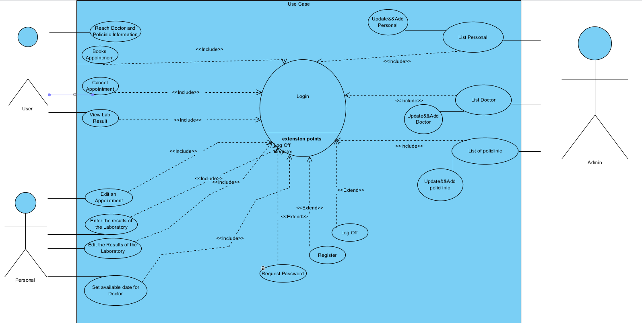

### Object model

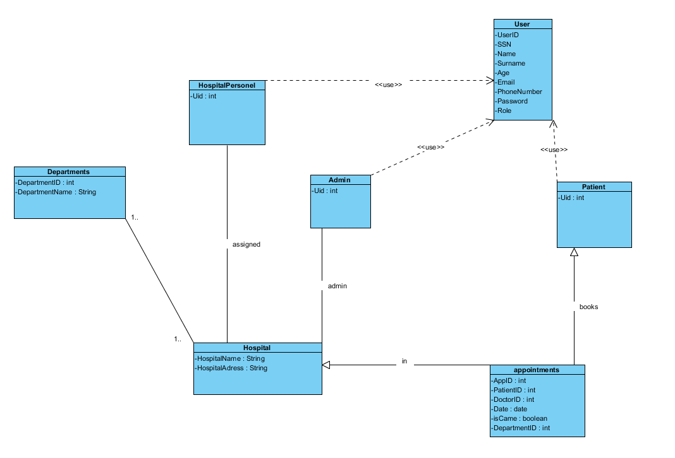

### **Dynamic model**

***Sequence Diagram***

***User-Book Appointment***

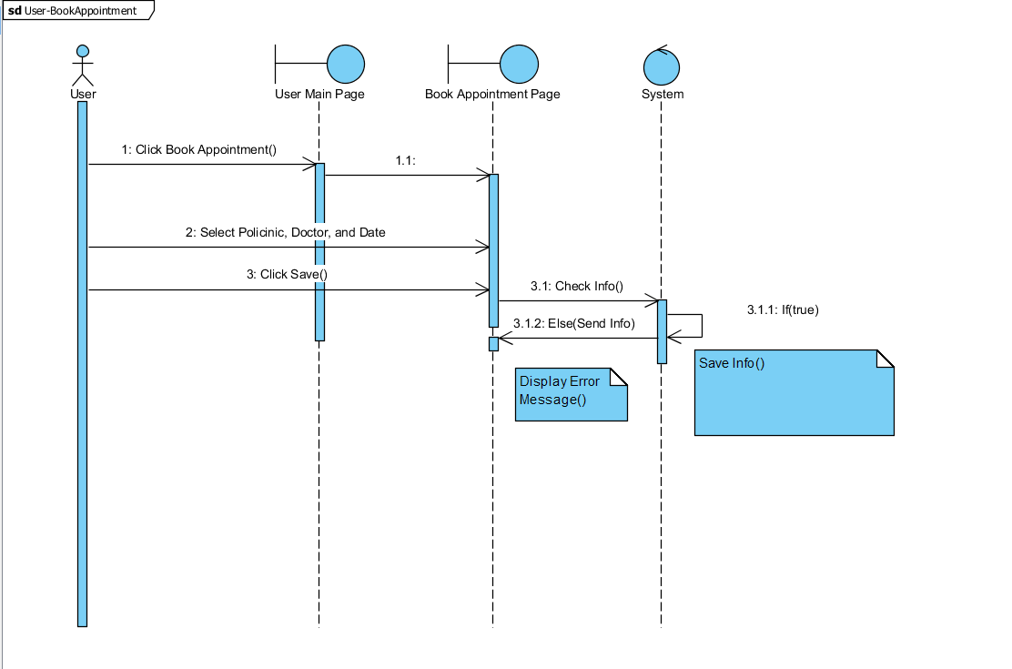

User-CancelAppointment

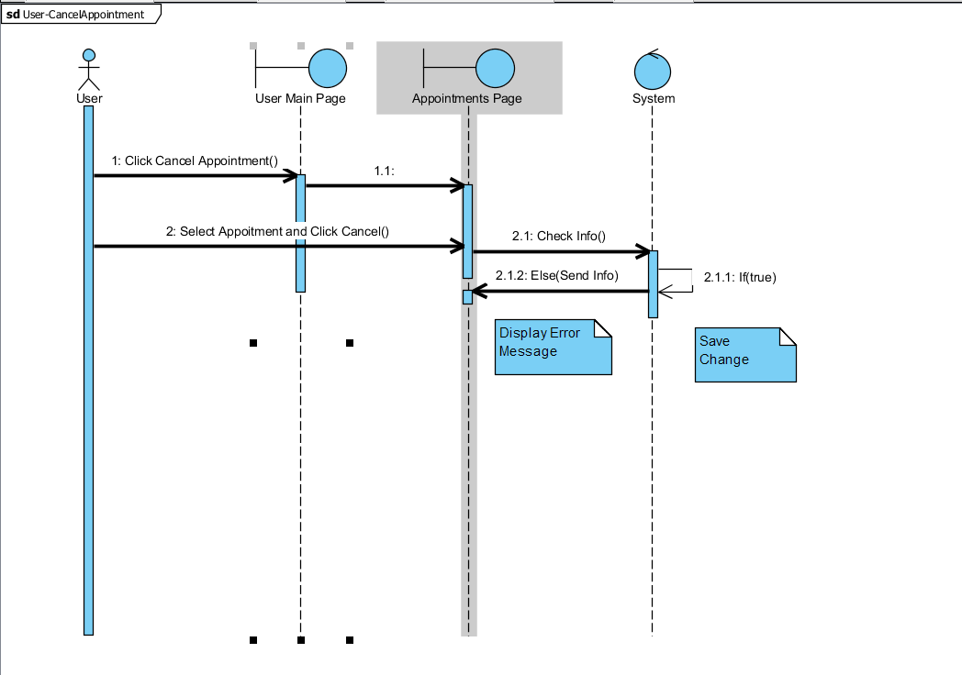

User-Login

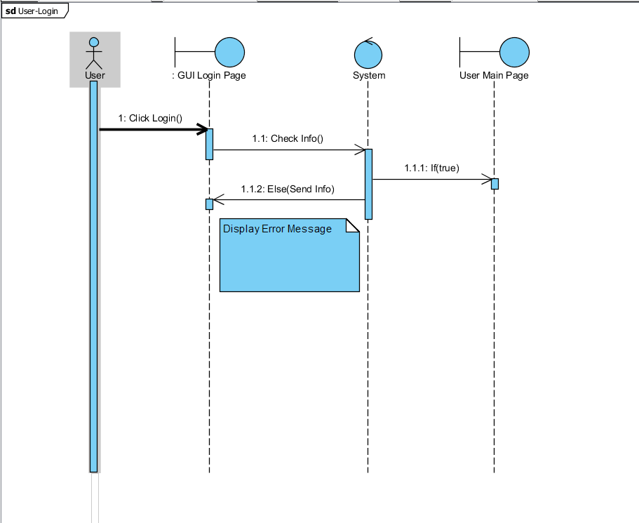

User-ViewLabResult

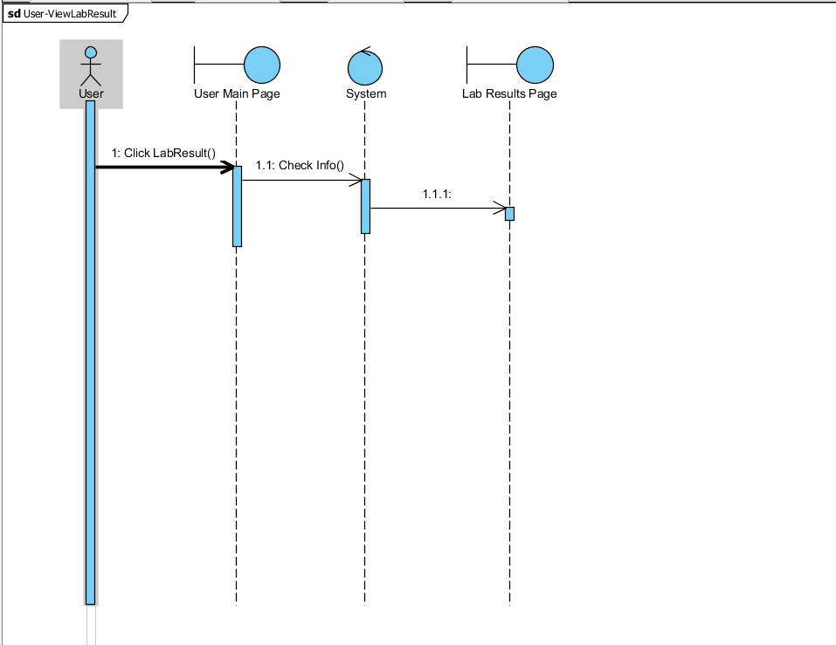

Personel Login

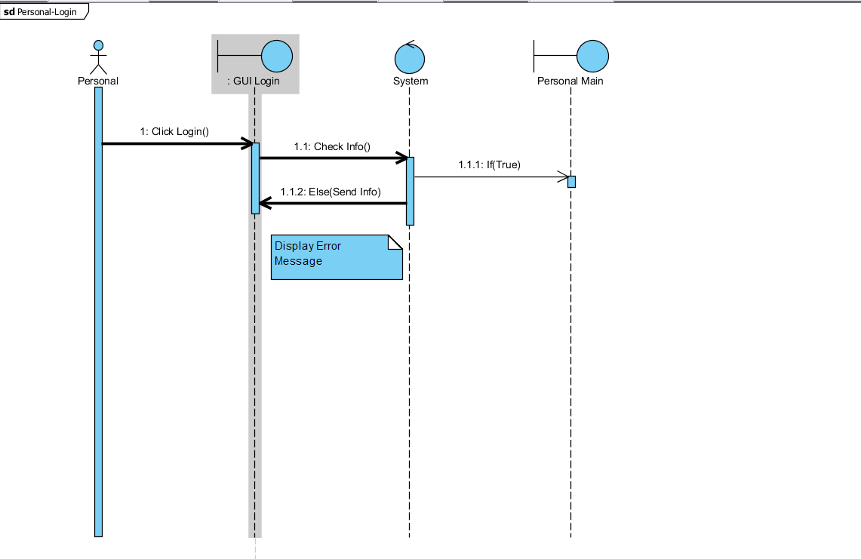

Personel-EnterLabResult

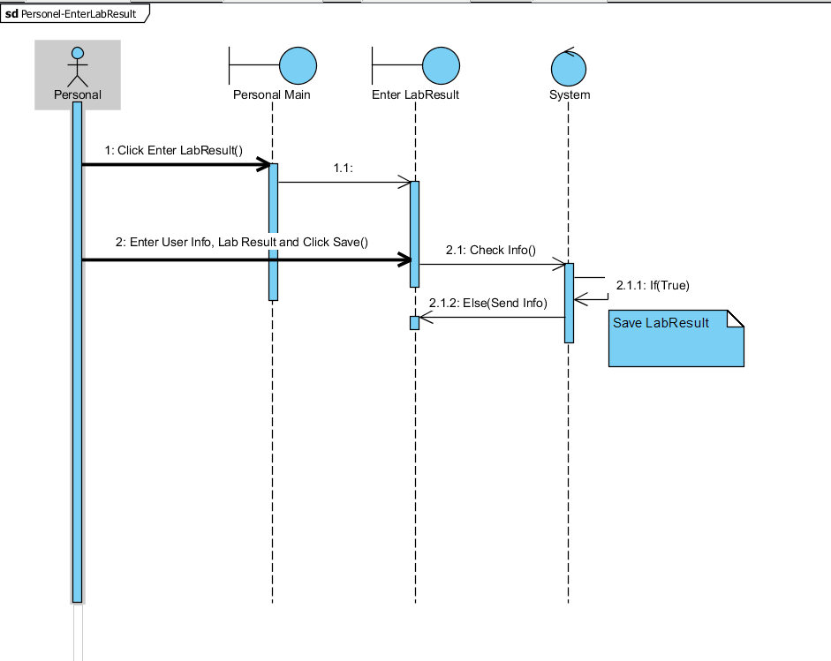

Personel-EditLabResult

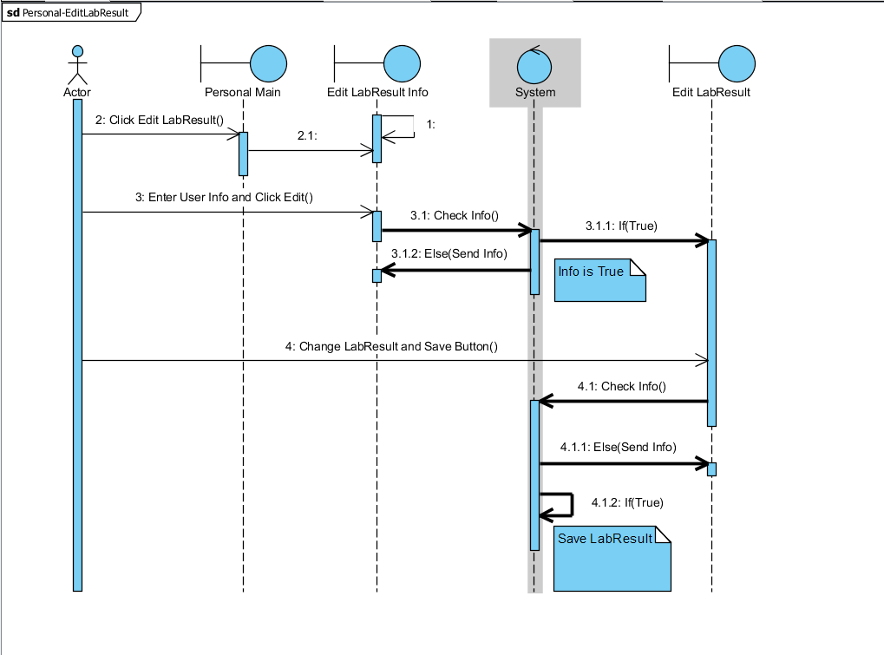

Personel-EditAppointment

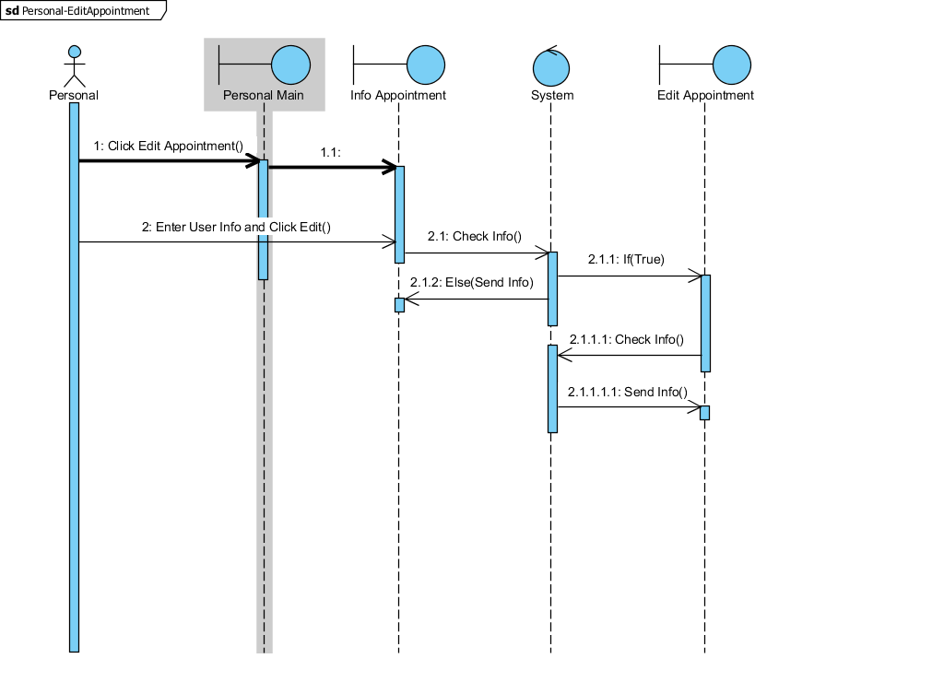

Personel-SetDoctor

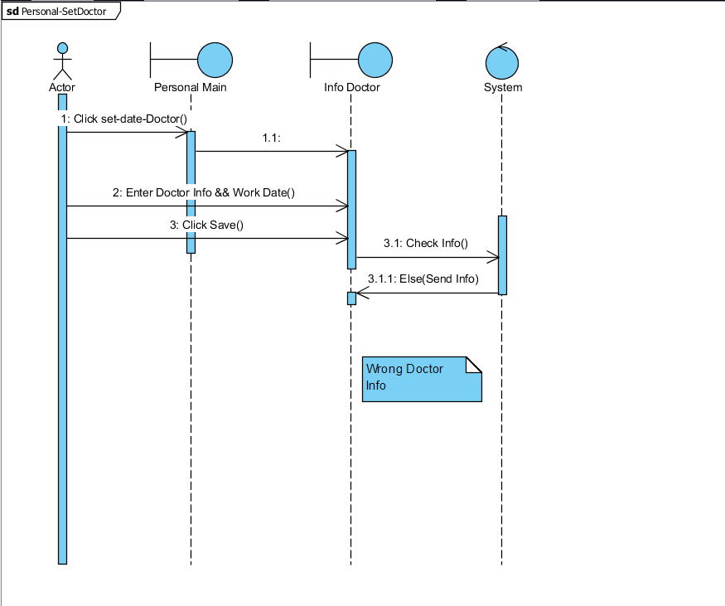

Admin-Login

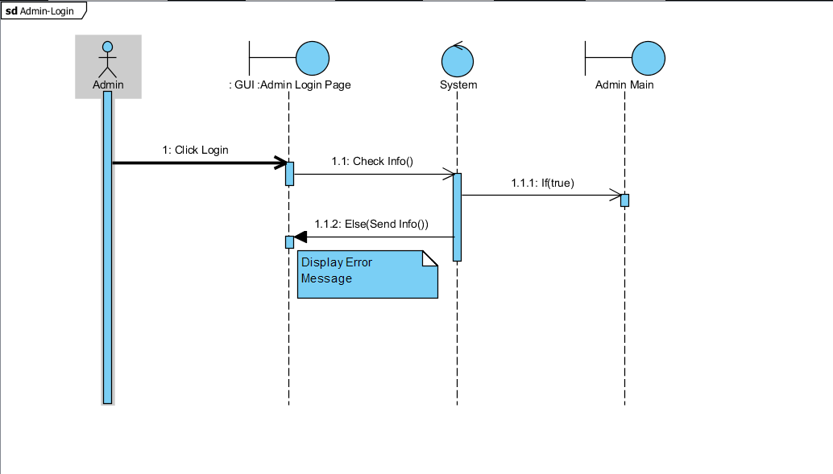

Admin­-List_doctor

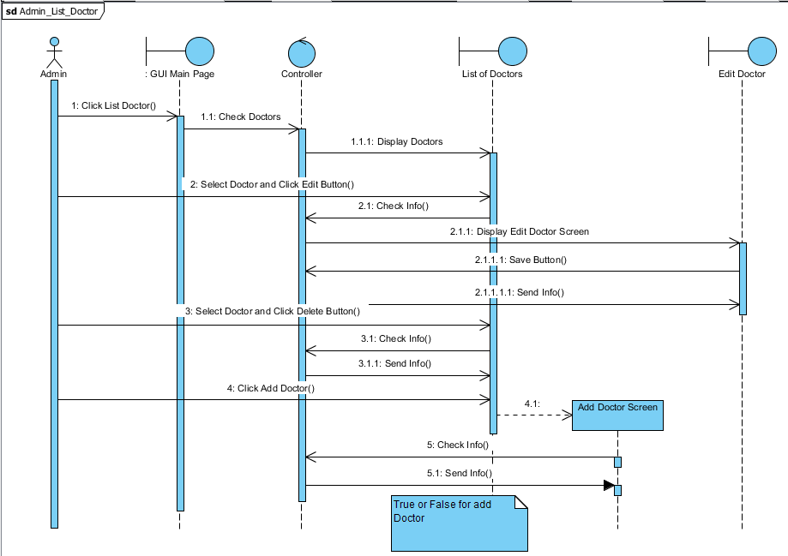

Admin policlinic

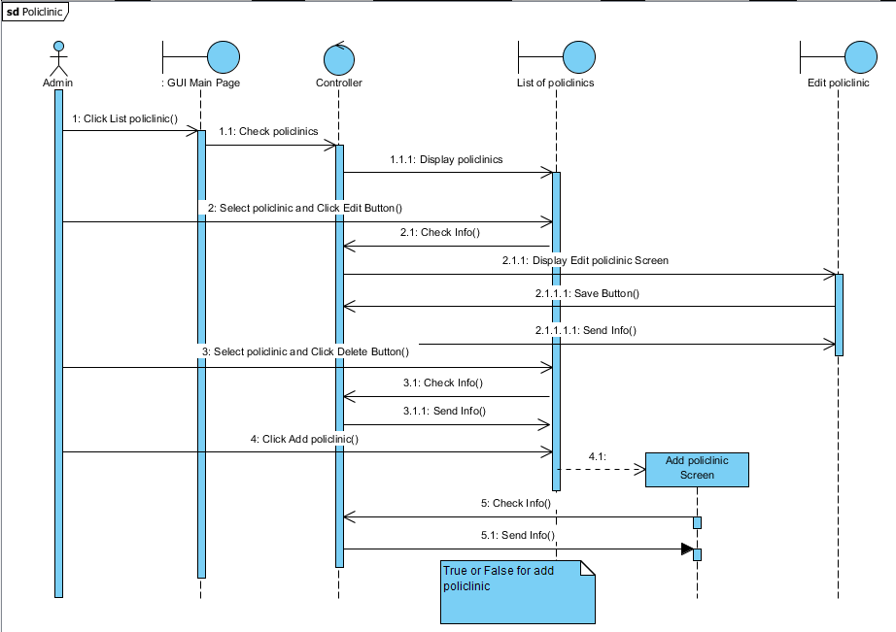

Admin-ListPersonel

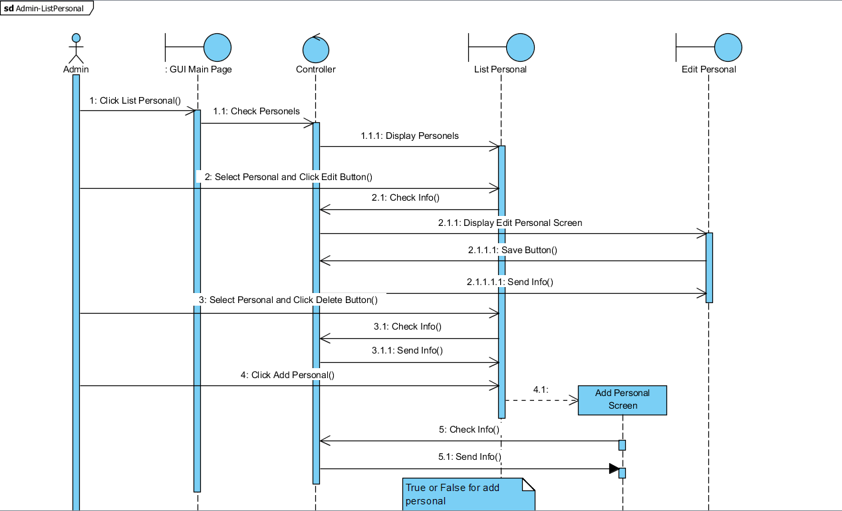

***Interfaces***

*Personnel UI*

*Doctor&Patient UI*

*Visitor UI*

*3.5 Project Schedule*

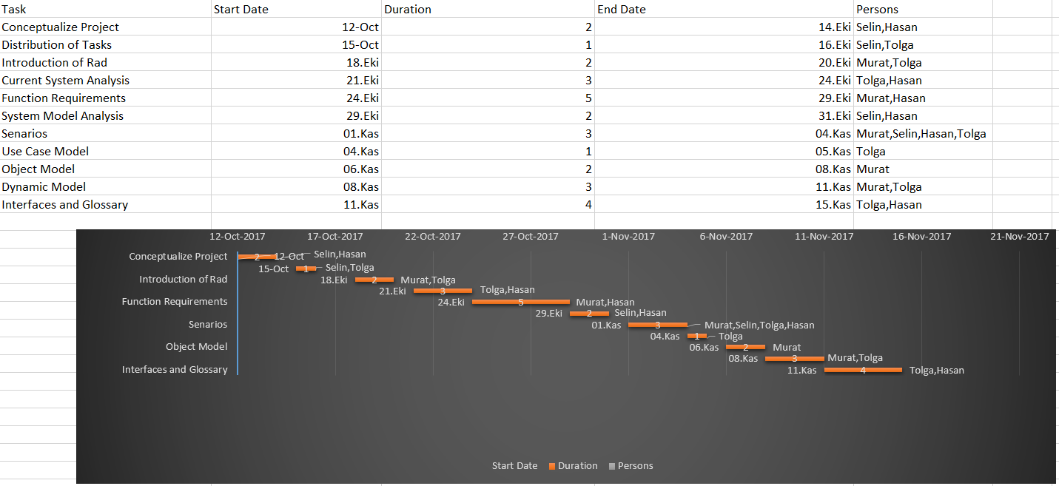

# Glossary

**Appointment**: Operation or order which is neccesary to doctor can examine the patient.

**Actor:** External entity that needs to exchange information with the system. An actor can represent either a user role or another system. In other words; a person, software system, or hardware device that interacts with a system to achieve a useful goal.

**Analysis:** An activity during which developers ensure that the system requirements are correct, complete, consistent, unambiguous, and realistic.

**Authentication:** The process of associating a person with access rights.

**Class diagram:** UML notation representing the structure of the system in terms of objects, classes, attributes, operations, and associations. Class diagrams are used to represent object models during development.

**Functional Requirement:** An area of functionality the system must support. The functional requirements describe the interactions between actors and the system independent of the realization of the system.

**Login:** Procedure used to get access to an operating system, or application, usually in a remote computer.

**Nonfunctional Requirement:** A user visible constraint on the system. Nonfunctional requirements describe user visible aspects of the system that are not directly related with the functionality of the system.

**Class:** A description of a set of objects having common properties and behaviors, which typically correspond to real-world items (persons, places, or things) in the business or problem domain.

**Exception:** A condition that prevents a use case from successfully concluding. The use case’s post conditions are not reached and the actor’s goal is not satisfied.

**Scenario:** A description of a specific interaction between a user and a system to accomplish some goal. An instance of usage of the system. Often presented in the form of a story.

**Sequence Diagram:** An analysis model that shows the order in which messages pass in a system or the chronological sequence of steps that take place in an activity and the entities or classes involved in the activity.

**Unified Modeling Language:** UML is a modeling language used to define a system prior to construction, much like a blueprint is used prior to building a house. It allows the project team to specify, visualize, and document an application, including its structure and design, in a way that meets all of the user requirements.

**Use Case:** A description of an interaction between an actor and a system that results in an outcome that provides value to the actor.

**Use Case Diagram:** An analysis model that identifies the actors who can interact with a system to accomplish valuable goals and the various use cases that each actor will perform.

**Life Hospital System**: Patients use the system to get an appointment and they go to doctor from the system.

**Hospital Personel:** Hospital Personel take a monthly program to doctor and them record these informations on the system.Also they can upload the information if it is neccesary.

**Admin:** Admin can reach all lists which are doctors, hospital personels and policlinics.And add, edit and delete their information.

**Patient:** Person who gets an appointment to go to doctor to be treated.

# References

1. UML Use Case Diagrams: Tips and FAQ

* <https://www.andrew.cmu.edu/course/90-754/umlucdfaq.html>

1. Introduction to Software Engineering/UML

* <https://en.wikibooks.org/wiki/Introduction_to_Software_Engineering/UML>

1. Bruegel B. & Dutoit A.H.. (2010). Object-Oriented Software Engineering Using UML, Patterns, and Java, Prentice Hall, 3rd ed.

# Mockups

**Mockup 1**

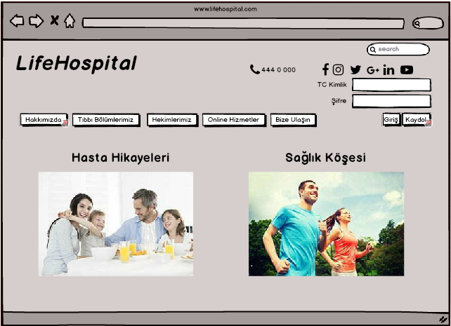

**Mockup 2**

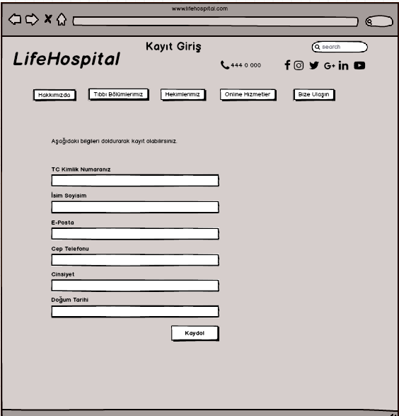

**Mockup 3**

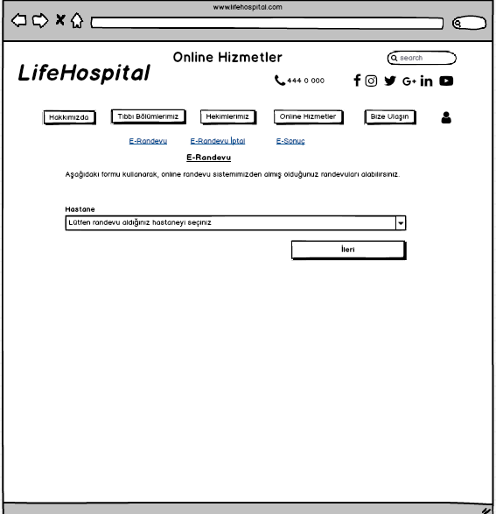

**Mockup 4**

